**TRAFFIC MANAGEMENT SYSTEM**

**PHASE -5**

**Objective:**

"Design and implement an IoT-based traffic management system with the following objectives:

Improve Traffic Flow: Optimize traffic flow by reducing congestion, minimizing delays, and enhancing the overall efficiency of transportation networks.

Real-time Monitoring: Enable real-time monitoring of traffic conditions, including vehicle density, speed, and road occupancy, to provide accurate and up-to-date information for both traffic operators and commuters.

Incident Detection and Response: Detect and promptly respond to traffic incidents such as accidents, breakdowns, and road obstructions by automatically notifying relevant authorities and providing alternate route suggestions to minimize disruptions.

Environmentally Sustainable: Promote eco-friendly transportation by optimizing traffic signal timings, promoting the use of public transport, and reducing unnecessary idling to minimize air pollution and greenhouse gas emissions.

Data-Driven Decision-Making: Collect and analyze traffic data to make data-driven decisions for infrastructure improvements, road maintenance, and future urban planning.

Smart Traffic Signals: Implement adaptive traffic signal control using IoT technology to adjust signal timings in real-time based on traffic conditions, reducing stop-and-go traffic and improving fuel efficiency.

Integration with Emergency Services: Collaborate with emergency services to enable fast and efficient responses during emergencies and disasters, ensuring the safety of all road users.

Scalability and Expansion: Design the system to be scalable, allowing for future expansion to cover additional areas and accommodate increased traffic demands.

Cost Efficiency: Optimize the allocation of resources and reduce operational costs through intelligent traffic management strategies.

Enhance Safety: Prioritize safety for all road users by implementing features such as pedestrian crossing signals, speed limit enforcement, and collision avoidance systems.

These objectives can serve as a framework for developing a comprehensive and effective IoT-based traffic management system that addresses traffic-related challenges and benefits the community as a whole.

**Role of IoT in Smart City Traffic Management:**

With the pressing demand for advanced communication & network technologies, digitalization is the driving force that stimulates the implementation of smart traffic control using IoT capabilities.

It enables them to;

* Expand the capacity of city streets without having to build new roads.
* Optimize the traffic flow and keep the drivers safe. It would include cameras, sensors, and cellular technologies that automatically adjust traffic lights, expressway lanes, speed limits, and highway exit counters.
* Transmit accurate information about available parking spaces to citizens in real-time
* Collect data on congestion and improve traffic signaling to reduce blockages and optimize commute
* Locate incidents and report them to emergency rooms immediately with road sensors and video surveillance
* Employ real-time data feeds to ensure the streetlights turn dim or brighten up per the changing weather conditions and the onset of day and night

Basic Diagram for traffic management system:

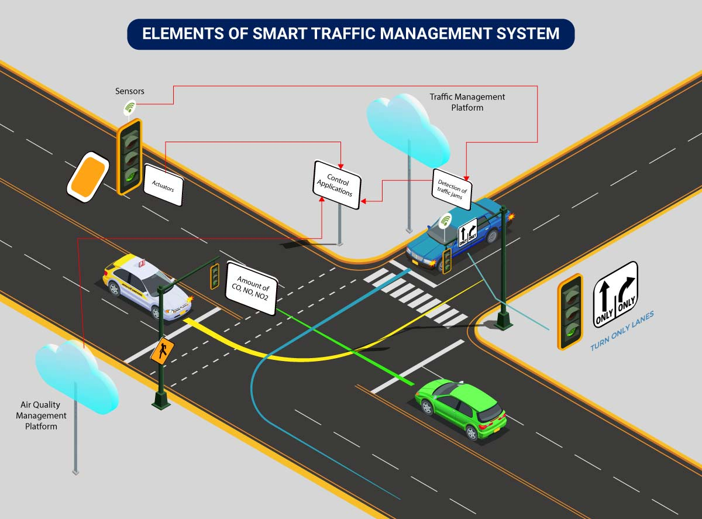

**Traffic lights control detection**

Components Required:

Arduino board (e.g., Arduino Uno)

3 LEDs (Red, Yellow, and Green)

3 220-330-ohm resistors,Breadboard and jumper wires

**Circuit Diagram:**

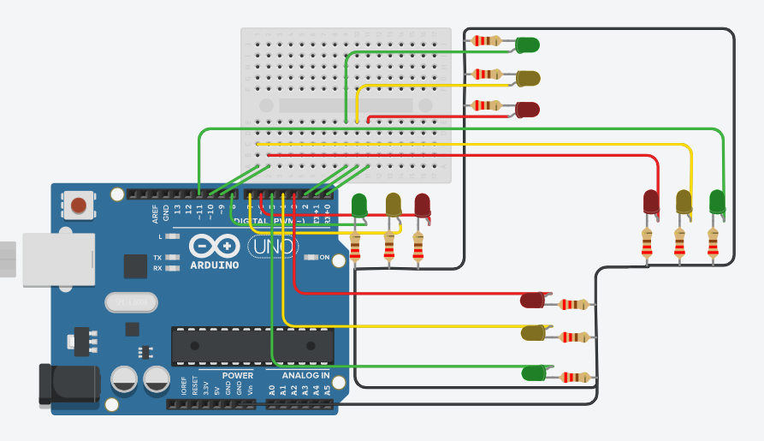

Code:

// Define the pin numbers for the traffic light LEDs

const int redPin = 8;

const int yellowPin = 9;

const int greenPin = 10;

void setup() {

// Initialize the LED pins as OUTPUT

pinMode(redPin, OUTPUT);

pinMode(yellowPin, OUTPUT);

pinMode(greenPin, OUTPUT);

}

void loop() {

// Red light (Stop)

digitalWrite(redPin, HIGH);

digitalWrite(yellowPin, LOW);

digitalWrite(greenPin, LOW);

delay(2000); // Stay red for 2 seconds

// Red and yellow lights (Prepare to go)

digitalWrite(redPin, HIGH);

digitalWrite(yellowPin, HIGH);

digitalWrite(greenPin, LOW);

delay(1000); // Stay red and yellow for 1 second

// Green light (Go)

digitalWrite(redPin, LOW);

digitalWrite(yellowPin, LOW);

digitalWrite(greenPin, HIGH);

delay(2000); // Stay green for 2 seconds

// Yellow light (Prepare to stop)

digitalWrite(redPin, LOW);

digitalWrite(yellowPin, HIGH);

digitalWrite(greenPin, LOW);

delay(1000); // Stay yellow for 1 second

}

Upload this code to your Arduino board, and the traffic lights should cycle through the usual sequence: red, red and yellow, green, and yellow.

Make sure to adjust the pin numbers if you connected the LEDs to different pins on your Arduino board. Additionally, you can enhance this project by adding a pedestrian crossing button or a light sensor to control the traffic light sequence based on real-world conditions.

**Vehicle Detection:**

Detecting vehicles using Arduino can be achieved using various methods, but one common approach is to use ultrasonic sensors to measure the distance between the sensor and the vehicle.

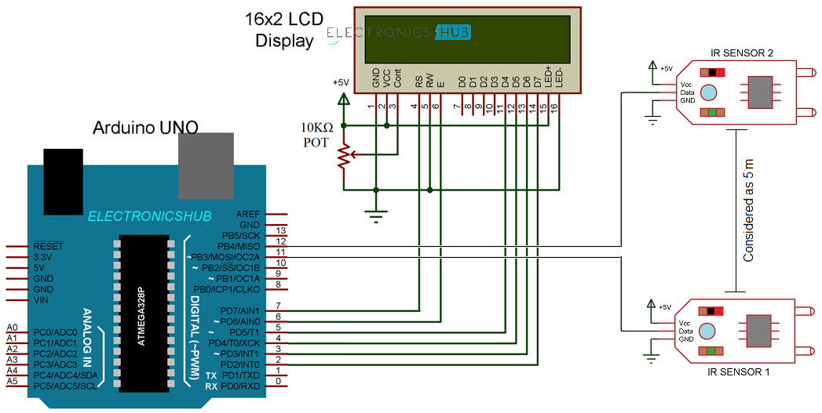

Code:

#include <NewPing.h>

#define TRIGGER_PIN 9

#define ECHO_PIN 10

#define MAX_DISTANCE 200 // Maximum distance for vehicle detection (in centimeters)

NewPing sonar(TRIGGER_PIN, ECHO_PIN, MAX_DISTANCE);

void setup() {

Serial.begin(9600);

}

void loop() {

delay(1000); // Delay for stability

unsigned int distance = sonar.ping_cm();

if (distance < MAX_DISTANCE) {

Serial.print("Vehicle detected at a distance of: ");

Serial.print(distance);

Serial.println(" cm");

} else {

Serial.println("No vehicle detected.");

}

}

In this code:

Include the NewPing library to interface with the HC-SR04 ultrasonic sensor.

Define the trigger and echo pins connected to the sensor, and specify the maximum distance for vehicle detection.

Initialize the **NewPing** object with the trigger and echo pins and the maximum distance.

In the **setup()** function, start the serial communication for debugging.

In the **loop()** function, wait for a 1-second delay for sensor stability.

Use the **sonar.ping_cm()** function to measure the distance to an object in front of the sensor.

Check if the measured distance is less than the maximum distance. If it is, consider a vehicle detected and print the distance. If not, print "No vehicle detected."

Make sure you have the HC-SR04 sensor properly connected to your Arduino with the trigger and echo pins. You can adjust the **MAX_DISTANCE** variable to change the detection range according to your specific requirements.

This is a basic example, and you can further enhance it by adding more sensors, integrating a display or alarm, or even using machine learning for more advanced vehicle recognition.

## Advantages of a Smart Traffic Management System

Cleaner, greener, safer, and more accessible roads are a few benefits of implementing IoT and intelligent technology.

It helps with the following:

* Reducing traffic jams and accidents on the streets
* Ensuring immediate clearance for emergency vehicles
* Facilitating safer and shorter commute times
* Reducing congestion & energy consumption at intersections
* Offering significant productivity benefits with real-time monitoring of crucial infrastructures
* Reducing operating costs with efficient traffic management processes
* Ensuring compliance with the regulations for reducing the carbon footprint
* Saving billions of gallons of fuel wasted every year
* Accurate tracking & quick recovery of lost and stolen vehicles

**Conclusion:**

In conclusion, the Traffic Management System project represents a significant step forward in addressing the growing challenges associated with urban congestion and transportation efficiency. Through the implementation of innovative technologies, data analysis, and infrastructure improvements, this system aims to enhance the overall quality of life for residents and visitors in our cities. It has the potential to reduce traffic accidents, decrease travel times, lower carbon emissions, and promote a more sustainable and accessible urban environment.

Top of Form